H.T No
Regulations:
A18

Sreenidhi Institute of Science and Technology
(An Autonomous Institution)
Code No: 7B309 Date: 28-Oct-2020 (FN)

B.Tech II-Year I-Semester External Examination, October - 2020 (Supplementary)
FLUID MECHANICS AND HYDRAULIC MACHINERY (ME)

Time: 2 Hours Max.Marks:70

Note: a) No additional answer sheets will be provided.
b) All sub-parts of a question must be answered at one place only, otherwise it will not be valued.
c) Missing data can be assumed suitably.

ANSWER ANY 5 OUT OF 8 QUESTIONS. EACH QUESTION CARRIES 14 MARKS.

1. | a) | Find the pressure at point 'A'.  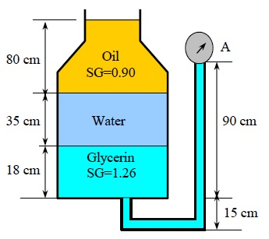 | [7M]
 | b) | Calculate the dynamic viscosity of an oil, which is used is used for lubrication between a square plate of size 0.8 m x 0.8 m and an inclined plane with angle of inclination 30⁰ as shown in figure. The weight of the square plate is 300N and it slides down the inclined plane with a uniform velocity of 0.3 m/s. The thickness of oil film is 1.5mm.  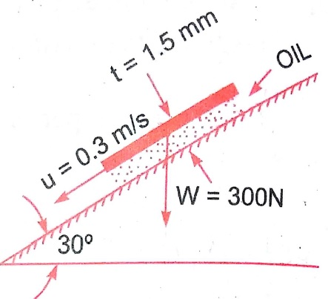 | [7M]
2. | a) | State different types of fluid flows? | [7M]
 | b) | The following cases represent the two velocity components. Determine the third component of velocity such that they satisfy the continuity equation.  i) u = x² + y²+ z²; v= xy² - yz² + xy  ii) v = 2y² ; w = 2xyz | [7M]
3. | a) | Find the head loss due to friction in a pipe of diameter 300mm and length 50m, through which water is flowing at a velocity of 3 m/s using Darcy formula. | [7M]
 | b) | The velocity profile for laminar boundary layer flows given as . Find an expression for boundary layer thickness (δ), shear stress and coefficient of drag in terms of Reynolds number. | [7M]
4. | a) | State Buckingham's π theorem. Why this theorem is considered superior over the Rayleigh's method for dimensional analysis? | [7M]
 | b) | The pressure difference ΔP in a pipe of diameter 'D' and length 'l' due to viscous flow depends on the velocity 'V' viscosity 'μ' and density '⍴' .Using Buckingham's π theorem, obtain an expression for ΔP. | [7M]
5. | a) | Explain the working of single stage centrifugal pump with neat sketch. | [7M]
 | b) | The diameter of an impeller of a centrifugal pump at inlet and outlet are 30 cm and 60 cm respectively. Determine the minimum starting speed of the pump if it works against a head of 30 m. | [7M]
6. | a) | A Pelton wheel has a mean bucket speed of 10 meters per second with a jet of water flowing at the rate of 700 litres/s under a head of 30 metres. The buckets deflect the jet through an angle of 160⁰.Calculate the power given by water to the runner and the hydraulic efficiency of the turbine. Assume co efficiency of velocity as 0.98. | [7M]
 | b) | Differentiate between impulse and reaction turbine? | [7M]
7. | a) | How vacuum pressure is measured? | [7M]
 | b) | Distinguish between compressible and incompressible flow. | [7M]
8. | a) | Define the terms dimensional analysis and model analysis. | [7M]
 | b) | Write a short note on water hammer. | [7M]

-- 00 -- 00 –

